WNP Open Space Walk No.1 (Susy Shearer and Nick Clemo, TG members)
On Sunday, 24th November 2013, Susy and I walked from Longbourn (Clewer Manor, Imperial Rd) down to St. Leonard’s Road and then out of Windsor along Winkfield Road where we particularly noted the general inadequacy of safe cycling provision. The footpath (on the NW side of the road) is a dual use path but is poorly marked as a cycle path and does not appear to be much used as such. More importantly, there is a sore need for good walking and cycling routes across Winkfield Road from West Windsor to provide access to the Park beyond. There is no decent public access across to the Park other than down Hermitage Lane (paths across Stag Meadow are suitable for walkers only) or, much closer in to Windsor, past the football ground.
In fact, we discovered a further permissive path across Crown Land, the half-hidden-entrance to which is almost across from Woodland Drive, which leads around a field edge to the west corner of Stag Meadow. The photos below show the entrance to the path from Winkfield Road looking from Windsor and Winkfield directions and its point of emergence into Stag Meadow.
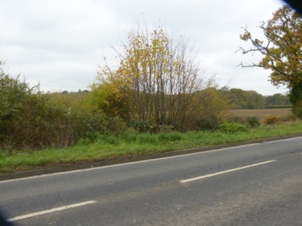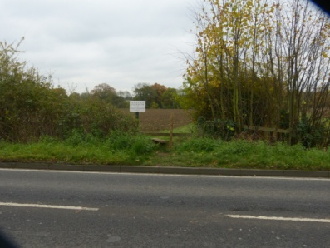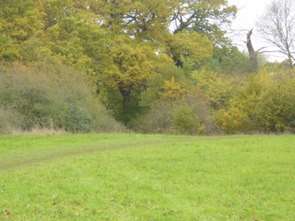
There is no safe crossing to the path from the footpath on the Legoland side of Winkfield Road however and the path is totally unsuitable for cyclists. We were both of the opinion that the whole area, and particularly routes into the park would benefit from better cycling and public footpath provision though that would require access across Crown land.
We continued our walk along the path into Stag Meadow and thence to the cycle trail from the football ground to the park. That path is a well maintained facility and much used for leisure purposes by walkers, runners and cyclists alike and shows what can be done with a little investment. Unfortunately it is only convenient for those already in Central Windsor. There is a point on the cycle trail at the NE end of Prince Consort’s Drive (see pictures below) which could be made to connect across to Legoland via Flemish Farm. This would, however, require substantial investment as well as Crown permissions.
