WINDSOR NEIGHBOURHOOD PLAN

Discussion Paper former IMPERIAL HOUSE SITE
Report Date: 21/12/2016
Report Authors: John Bastow, Claire Milne

1. Objective
To take a deeper look at the issues relating to this site and hence to agree a way forward for our policy on this site.

2. Introduction
2.1 RBWM has identified the former Imperial House site in their Borough Local Plan Regulation 14 (December 2016) – herein after “the BLP” - as a Strategic Employment site. Ref Policy ED2 (p80). The site has planning approval for the erection of large office complex.

2.2 The WNP Pre-submission Draft (Sept 2016) Ref Policy IH01 (p83) – herein after “the WNP” - supports a policy that in the event of the above approval not proceeding then the site should be used for a medium density housing scheme (terraced houses and flats) or failing that as an (undefined) mixed use scheme combining housing with commercial space.

2.3 RBWM contends that the WNP policy goes against NP “Basic Conditions”, that is the need for NPs to “generally conform” with RBWM Strategic Policy that this is a designated employment site. So RBWM considers that the WNP policy conflicts with the RBWM plan and the implication is that the WNPlan will not pass Examination as a result.

2.4 The way forward suggested by AECOM is:
1) Enter into discussion with the Council regarding the site
2) If deemed necessary, undertake further evidence-gathering work
3) This could include a targeted consultation on the site, with explicit consideration given to the merits of residential option(s) vs employment option(s) and compromise positions of mixed use options
4) EITHER Finalise the plan for Regulation 15 submission in-light of the new evidence (and all other evidence, e.g. responses received through the recent Pre-submission consultation)
5) OR Reword policy IH.01 to maintain the principles but to delete explicit reference to housing and at the same time, respond to the BLP with our arguments against the use of the former Imperial House site for employment.

2.5 AECOM have explained to RBWM that the WNP could explore compromise positions which would allow them to progress to submission asap (i.e. without a Strategic Environmental Assessment - herein after “SEA”- and a second formal Regulation 14 consultation), although the WNP Committee is not unanimous in this view.

3. Site Options: analysis evidence and policy context

3.1 Why does RBWM support Employment use on this site?

The retention of employment land and employment allocations is regarded by the BLP as a matter of considerable strategic importance as stated in the BLP Objective 4 - “to enable the evolution and growth of the local Business economy” and BLP Strategic Policies, ED1 Economic Development, ED2 Defined Employment Sites and ED3 Other sites and Loss of Employment Floor Space.

3.2 BLP employment land requirement evidence comes from several sources. These include:
- The Thames Valley Berkshire Local Economic Partnership Strategic Economic Plan for Berkshire,
- Housing Market Areas and Functional Economic Market Areas (2015 Nathaniel Lichfield and Partners) identifying the Functional Economic Market Areas, (FEMAs)
- East Berkshire Economic Development Needs Analysis (EDNA),
- The RBWM Housing and Employment Land Availability Assessment 2016 (HELAA).

3.3 The outputs from these studies show three scenarios for floor space requirements to support economic growth in the BLP Spatial Strategy (p32), but acknowledges that there are many uncertainties in such forecasts and they are highly sensitive to assumptions (BLP Paras 5.3.13-17).

3.4 The BLP has concluded that there is a need for 41,400m² of employment floor space over the period 2013 to 2033 within RBWM.

3.5 The inference is that this site, at 25,500 m² is intended to provide well over half of the employment floor space required by the Borough over the plan period and therefore we can infer that the site it is critical for RBWM and that no other equivalent sites have been identified within Windsor.

3.6 The site location is within 10 mins walking distance south west of the town centre and central station and is a location that can sustain denser development. This is in line with BLP policy for sustainable locations for offices and higher density developments (xxxx).

3.7 RBWM contend that if it is lost as a site for employment then alternative allocations will be required - probably in the Green Belt (which means further out of Windsor because of the constraints), although no such sites have been identified.

3.8 It is also argued that Windsor’s economy has lost many office jobs over the last few years and that this office development will help redress this decline and keep Windsor as an important employment centre. Because recent conversion of offices to flats (through national legislation on permitted development rights) has threatened Windsor’s critical mass and attractiveness for office based businesses, the RBWM is proposing an Article 4 direction to exempt central Windsor from the national legislation to prevent further such losses. Use of this major site will help to mitigate such loss of space and loss of commercial jobs thereby helping Windsor retain its commercial importance.

3.9 The advent of Crossrail may change the dynamics of the area’s economy in ways we don’t yet know, but this site could become more attractive and therefore in demand as it is close to the centre of Windsor. Similarly a third runway at Heathrow would likely increase local demand for such space.

3.10 Windsor is generally regarded as a prestige destination. If this site were to attract a prestigious employer, then it would be good for Windsor as a whole. The multiplier effect would be advantageous for the local economy as has been demonstrated by LEGOLAND.

3.11 Employment here would provide jobs for people living locally, as well as others from further afield. The effect on commuting is worth debate but it is certainly likely to increase the numbers of journeys of both. It is therefore likely to have a negative effect on pollution.

3.12 Employment use would create a one-off lump sum for RBWM from CIL /Section 106 contributions and ongoing income from Business Rates (find out how much).

4. Arguments against employment uses

4.1 The evidence documents that RBWM has used are Borough wide rather than based on purely local conditions in Windsor. The Economic Development Needs Assessment - herein after “EDNA”- says that the forecast need for employment space is difficult to predict and is highly sensitive to local conditions and assumptions made during the analysis. The report admits that the forecast may not be accurate.

4.2 The EDNA report dated October 2016 (published by Central Berkshire FEMA) notes that …… Reading and Windsor & Maidenhead record the highest amount of office space.

4.3 Commercial space is defined by class of use. There is a distinction to be made within the B1 Business classification: (a) is office space and (c) is light industrial space. B2 is factory and B8 is warehousing. BLP Para 8.2.12 suggests that there is a higher need for B1 space - but which? - and a lower need for B2 warehousing - suggest error in class use here. In particular, translating the forecast demand between different use categories e.g. office and/or light industrial and/or warehousing space is especially difficult and highly sensitive to assumptions.

4.4 The WNP submits that local evidence suggests that;
- the surrounding area is full of vacant office space (type a) but
- there is a greater need for light industrial space (type c), as typified by activity at the Fairacres Industrial Estate.

4.5 Therefore there is not only a considerable degree of uncertainty around the evidence for the amount of office space needed, but also something of a mismatch between this site and what the market actually wants.

4.6 Given this uncertainty, any decision comes down to a judgement as to what the overall most advantageous use would be for all concerned.

5. Parking and access

5.1 The site offers 495 parking places. Potentially around 2,100 employees would commute to and from the site, which indicates how many cars per day would access the site along Alma Road and into the existing, single narrow access road. This vision is not popular with residents in the immediate vicinity.

(The calculation of number of employees on site is based on a figure of CHECK 12/10m²)

5.2 The Planning Permission Appeal in 2011 included a condition of a Travel Plan and the need for additional off-site parking at a 400 space Park & Ride at either Windsor Racecourse, Legoland, or the Home Park, to accommodate those cars which could not be accommodated on site. This prospective P&R facility has never been forthcoming and there is no clarity as to whether there is capacity at either site or whether Windsor Racecourse, Legoland or the RBWM want it and so the question of where will the additional parking be accommodated has not been answered.

6. The demand for offices

There is evident demand in the Thames Valley for offices and at present low office vacancy rate in the Thames Valley Area so in theory the site should have a high chance of being let.
A third runway at Heathrow may also add to the local demand for offices. The Brexit risk may have temporarily hit demand for the time being. NO THIS NEGATES EVERYTHING WE SAID ABOVE.

6.1 The current developers indicated earlier on that they would not commence the project until they had a 25% pre-let commitment. To date it would appear that this condition has not yet been satisfied and the site remains still.

6.2 The NPPF Para 22 states that, “planning policies should avoid the long term protection of sites allocated for employment use where there is no reasonable prospect of a site being used for that purpose. Land allocations should be regularly reviewed. Where there is no reasonable prospect of a site being used for the allocated employment use, applications for alternative uses of land or buildings should be treated on their merits having regard to market signals and the relative need for different land uses to support sustainable local communities.“

6.3 The WNP is of the opinion that the situation is tending towards “long term protection” and therefore will support the consideration of a decision date for the future of the site.

6.4 In June 2016 planning application 16/01784/FULL was submitted to RBWM in respect of the adjacent Hovis Court and a partial change of use for half of the block from B1 (office) to a specialist Cancer Care Centre and associated offices and works. The associated Planning Statement submitted by consultants Lambert Smith Hampton (para 7.3) states inter alia that, “However, although market evidence indicates that no demand exists for a B1 office use at this location, ……………….. “.
6.5 It is noted that the offices on this site are around 2,500 m², so although a lot smaller than the proposed Imperial house site. Although the site had permission to almost double in size, the prospective new occupants say they are not going to expand the size but will use the existing building which better suits their needs.

7. Arguments for only Housing uses or mixed uses

7.1 The WNPs policy IH.01 p83 for a mainly housing preference on this site came about through our many consultations and research phases.

7.2 As the only brownfield site within the WNP area and with a considerable and controversial planning history, it was identified early on by the WNP Forum. The site had also been included in RBWMs earlier (2013) consultation on prospective sites for development, and results had also showed that a majority of respondents supported housing uses on this site. Subsequent proposals to sell the police station made it clear that however this extended Alma Road site is developed, it should desirably be done as an integrated whole rather than in a piecemeal manner.

At this point hearsay evidence was that RBWM and the local business community supported employment uses although at that time there were no specific RBWM Evidence documents seen in support of that line, and these didn’t become available until very recently (Nov 2016) that is AFTER the WNP Reg 14 Pre-Submission consultation. NOT TRUE

7.3 The Windsor business community have never supplied any formal statement or communication to us about this site, although some individuals have given feedback on some consultations, and informal comments, but none of these have amounted to formal communications on WNP policy proposals.

7.4 In 2014 The WNP Forum decided to press on with consultations on this issue and in the Jan 2016 Options Consultation put forward several alternative residential schemes on this site for consultation, as well as asking respondents for views on employment uses.

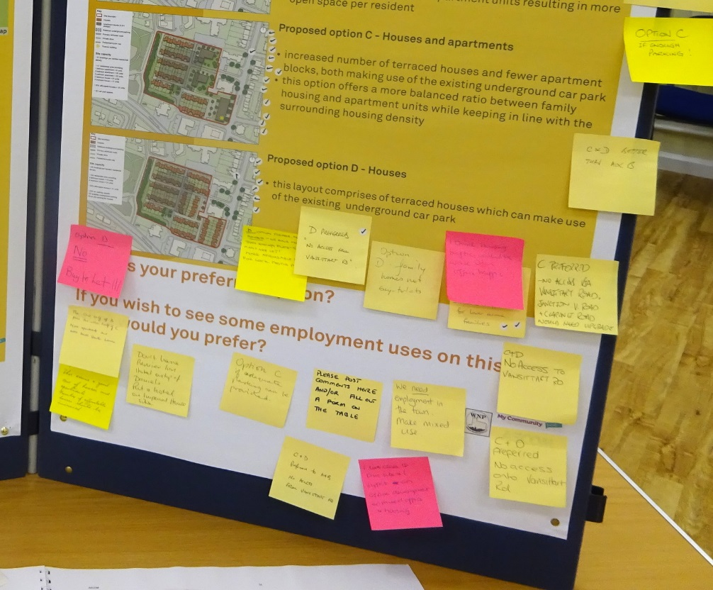
7.5 Our consultants AECOM had submitted a number of options in various combinations of housing, apartments and commercial use. For public consultation we narrowed these down to 4 residential options (A thru D) which we submitted to public consultation in Jan/Feb 2016.

7.6 The preferred solution was Option C, a wholly residential site broadly in line with the RBWM findings in 2013; namely a mix of houses and apartments. This was supported by 58% of on-line respondents.

7.7 Our presentation board (see photo) at the two public open days in January 2016 also posed the question, “If you wish to see some employment uses on this site, which would you prefer?” There was a very small take-up.
- one post-it note recorded that, “We need employment in the town. Make mixed use” and
- the supporting Survey Monkey on-line free text responses included only 3 out of 26 comments favouring some employment space.

7.8 We conclude that residential space remains the public priority.

Our Pre-submission policy wording was developed with our research in mind and the probable differing view points of residents and the business community and RBWM. Our policy wording did deliberately keep the door open for the potential for mixed housing and employment uses as a pragmatic and balanced response to the need for employment space, although some residents living close to the site are pushing hard for purely residential. I HAVE A PROBLEM WITH THIS. IN THE EVENT THAT EXISTING PLANS WERE NOT REALISED WE SUPPORTED WHOLLY RESIDENTIAL.

8. Why Housing only?

8.1 There is an established need for all types of housing in the WNP area and although RBWM has now identified sites to provide a % year land supply ???? these sites are still under consultation.

8.2 WNP consultations indicated a Preferred Option for medium density housing on the site, creating xxx units, in both apartment blocks and terraced housing in keeping with the nearby streets.

8.3 This quantum of development is lower than that in the current planning permission for offices and is unlikely to be accepted by the site owners as it would generate insufficient return. They would seek high density housing that would generate a similar quantum of floor space as the office development and therefore potentially generate a similar level of profit.

8.4 As a substantial site it would be expected to deliver a substantial amount of affordable housing. BLP Policy seeks 30% Affordable.

8.5 Housing uses would generate potentially the following income for RBWM:
CIL: £240 sq ft
S106: x
Annual Council Tax: x

9. Infrastructure

9.1 Why Housing and employment Mixed use?
Arguments needed here

9.2 SEA
RBWM has also questioned whether the WNP needs a Sustainability Appraisal/Strategic Environmental Assessment as a result of the Imperial House Policy (and the Dedworth Road Urban Design policy). Conversely, we have been advised that it is unlikely that an SEA would be required, but in the event of a change to our policies it could mean one is required.

9.3 An SA/SEA is normally required when sites are “allocated” for particular uses in an NP. RBWMs Planning Policy officer (Robert Paddison) has recently expressed a view that that the WNP policy amounts to an allocation of this site for housing. AECOMs SEA expert (David Fessey) is firmly of the view that this is not necessary given that our policy does not actually create a “red line” around a site allocating it for housing, but simply states a preference for a particular outcome for it as a basis for future discussions with RBWM. We need to consider this issue in our deliberations.

9.4 Remaining funds are insufficient to support both an SA/SEA and a new Reg14 consultation, therefore under such circumstances more funding will need to be obtained to support the extra work, either from RBWM or from Locality/Dept of Communities and Local Government.

9.5 The implication for the WNP following the advice received so far from consultants is that any decision on this site to support residential redevelopment should be more firmly evidence-based which may involve more consultations to explore other mixed use options (see WNP Master Plan). And should our ultimate policy decision be amended and/or should our policy then need an SA/SEA, then the WNP will have to undertake another Reg14 Consultation.

10. Summary

- WNP current policy IH.01 for housing or mixed use conflicts with RBWM Strategic Policies for employment on the site in perpetuity
- The site already has Planning Permission enacted although it has not yet met Transport Plan and Parking conditions .
- RBWMs site policy could be argued against on the basis of a) Uncertainty of forecasts and interpretation of evidence b)Parking conditions not having been met c) Access and traffic generation d) Demand evidence
- WNPs Preferred Option for Medium density housing would not be viable for the developers who would be unlikely to apply for PP for this option, so this is an unrealistic policy choice. High density housing would be more viable for developers. The WNP should consider whether to research/propose this option.

11. Conclusions

Here are WNP options for action on policy IH.01 and IH.02

- Ignore RBWMs view, and press ahead and get our WNP Peer reviewed as it is to get another independent view. This goes against AECOMS advice to negotiate with RBWM and ultimately may result in delays to our NP if the independent view advises the need for more consultations and evidence.
- proceed with discussing with RBWM for the current WNP policy for medium density housing only e.g. existing policy with a defined review date (say 5 years). Get additional Housing evidence from Desk research to build a better supporting case. We already know that this policy may be unrealistic as it is of insufficient density to be viable for the developers, although it is the one supported by the majority in our consultations. As a result we may need to consider researching the case for higher density options for housing as this would be more likely to be viable.

- proceed with discussing with RBWM for the existing WNP policy for mixed use with a time lag for review at the same time as seeking consultation evidence for this option as we don’t currently have much as well as more desk research to build a better supporting case.

- amend the policy so that it meets basic conditions of general conformity to BLPs employment uses as per David Carlisle advice, while at the same time challenging the BLPs insistence on the site being designated wholly for employment. e.g. by challenging the employment uses that the site is being proposed for-propose small business uses/incubator type area? Not sure if it is possible to find words that will do this or if we have the evidence to do it This should result in the least delays to our NP.

- delete the policy.

11. RECOMMENDATIONS

Option d

APPENDIX 1

Site History: Chronologically

2005: Rank Hovis McDonald moved out of Imperial House and relocated to Hovis House (adjacent and considerably smaller). Inter-Continental Hotels then refurbished Imperial House and it was used at its UK HQ until 2008 when they moved to a purpose built site in Denham.

2008: the Crown Estate sold the site to Europa Capital and the office block was offered for rental from that date onwards. There was, possibly a short duration occupation by Reckitt & Coleman - now Reckitt Benckiser. It then remained vacant until demolition.

2008, 21 April: planning application 10/00820/FULL submitted to RBWM

July 2008: Europa Rock s.a.r.l. began local consultation with the RBWM, MP Adam Affryie etc. and there was a subsequent local consultation on site for different proposals later in the year.

2010, 12 July: RBWM refused planning permission

2010, 21 December: Planning Appeal heard (Ref: APP/T0355/A/10/2134960)

2011, 9 February: Appeal Decision given against RBWM. Condition (1) noted that the development hereby permitted shall begin not later than three years from the date of this decision.

2014, January: demolition began and therefore the planning permission now has no time limitation. The original developer had sold the site in June 2013, having not been able to find any company or companies who were prepared to take a pre-let before building commenced. To date Salmon, the new agents have found the same problem.

Site History: Other

It is the only major brownfield site in the WNP Area.

It lies adjacent to two other office blocks to the south and east:
i) Hovis Court for which planning permission was granted in 2016 for a Cancer Centre and
ii) the Police Station (currently empty and expected to be sold in 2017) and

iii) the RBWM Alma Road Youth and Community Centre.

It is on the edge of the Trinity Conservation Area and is bounded by housing and community uses on the north and east side and Vansittart Recreation ground on the west side. In addition there is a Social Club, a Holiday Inn Express Hotel and a vetinary establishment to the south on Alma Road.

A doctor’s surgery and sheltered apartments lie to to the north.
The area is therefore a mix of residential area to the north and west and a more commercial area to the south. NO. DO NOT AGREE. THIS IS NOT COMMERCIAL TERRITORY

In February 2016 we met with Salmon Property, the developers. They told us informally that it had been and remained their intention not to start work until 25% of the new capacity had been let.

APPENDIX 2

AECOM Opinion

It does not necessarily follow that an SEA is necessary. We still do not know why.

RBWM argue that support for residential redevelopment / loss of the employment allocation could lead to significant environmental effects in the sense that there will be an effect on out-commuting and in turn CO2 emissions, traffic and air quality. The WNP supports the counter view that the intensity of traffic commuting to an employment site could have at least an equal effect and at worst a greater effect.

APPENDIX 3

Have deleted all extracts from our Plan. I do not think we need to repeat all that in this document.

